Group 2

Cabeza, Edgar Jr.

Baldeo, Oliver

Diaz, Francious Mico

Salivio, Johnas

Pestanas, Ivan

Site Map:

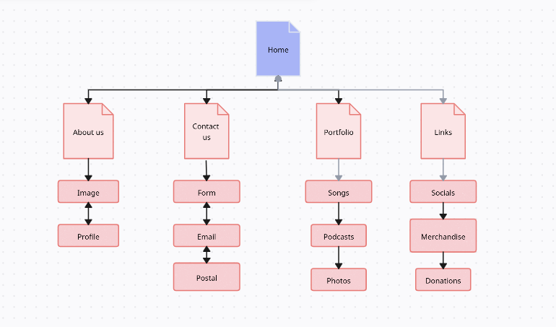

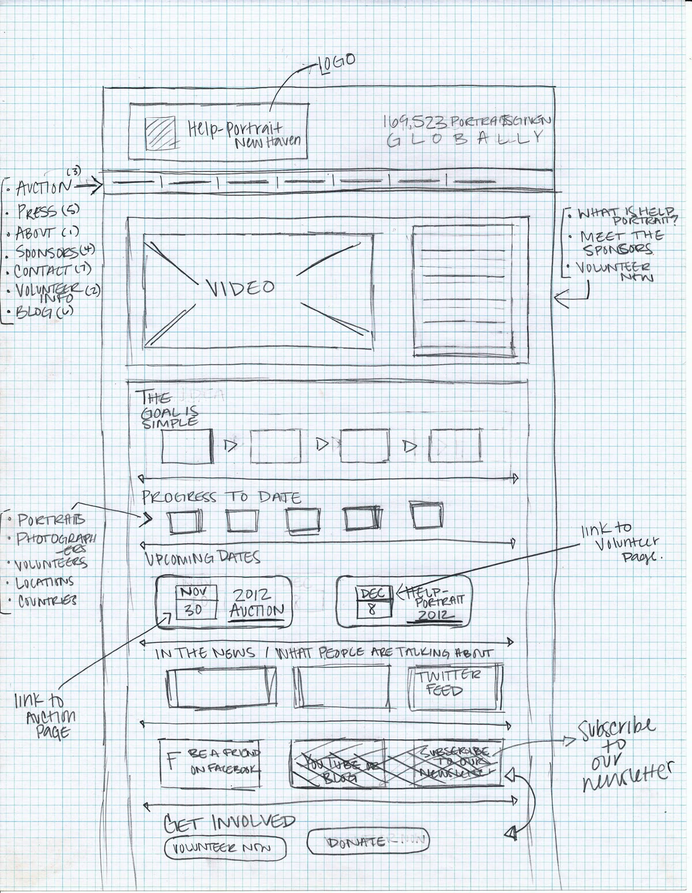Wireframe template:

